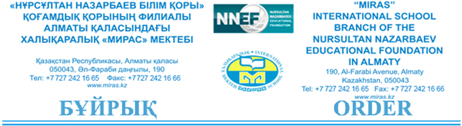
№ 50 - П

March 16, 2020 Almaty

Re: Organizing the activities of
Miras International School Branch of
“The Nursultan Nazarbaev Educational Foundation” in Almaty
for the period of emergency situation due to coronovirus infection

In connection with declaring the state of emergency due to coronovirus infection as well as pursuant to the order of the Minister of Education and Science of the Republic of Kazakhstan dated 14/03/2020 #108 “On Strengthening the Measures to Prevent the Spread of Coronovirus Infection COVID-19 in the Organizations for Orphans and Children Left Without Parental Care during a Pandemic Period,” I HEREBY ORDER:
- To prohibit any mass gatherings at school from March 16 to April 15, 2020;
- To determine the length of the school holidays as 21 days from March 16 through April 15, 2020;
- To establish the following groups of staff:
- The employees who maintain the school operations (the administrative and support staff);
- The staff, who are involved in the learning process based on remote technology (the teaching staff);
- The staff, who are going to be on leave.

- To establish the following working hours for the administrative, teaching and support staff at Miras International School Almaty:
1) The school administration works in an ordinary way. They shall ensure a school operation as well as effective distance learning;

2) The teaching staff shall start holding distance lessons for students from March 16 to April 15, 2020; developing professionally online. Responsible persons are D.Ashirbekova, P.Harrison, L.Mikhailova, E.Vladimirova, G.Myrzakanova;

3) The support staff shall work in an ordinary way to maintain the school operations;

4) The translators of English/Kazakh languages for the period from April 16 to April 15, 2020 shall work online, submitting reports on their activities;

5) The single subject teachers shall be on annual leave from March 16 to April 15, 2020 (physical education, music, psychology) if they are not involved in in remote learning process. Also, it refers to the assistant teachers of preschool and primary school, the lab assistants of secondary school and the support staff as agreed by the school administration.
- On 16/03/2020 the PS and SS Vice-Principals shall develop the procedures and action plans on students, monitor distance learning regularly from March 16 to April 15, 2020. (Responsible persons: P.Harrison, E.Vladimirova, L.Mikhailova, E.Vladimirova, G.Myrzakanova);
- The teaching and support staff, who are involved in distance learning, shall regularly look through Outlook/WhatsApp, e-mails and respond to requests from the school officials in a timely manner as well as keep in touch with parents and students (it refers to teachers);
- IT-administrator A.Mukhamedin:

- To develop instructions in writing and to organize trainings for teachers on using Office 365 (Teams, with the integration of OneDrive). The deadline is March 16, 2020. Responsible person is A.Mukhamedin;

- To provide the staff with access to online work for the period from March 16 to April 15, 2020.
- School doctor R.Kuramissova shall take enhanced measures on the sanitary, epidemiological, preventive safety and security of this school in accordance with the requirements and recommendations of the Kazakhstani state authorities and ensure that the sanitary requirements are fully observed.
- School doctor R.Kuramissova shall make arrangements on taking the school staff’s daily temperature before entering the school grounds.
10. Head of HR-Department I.Nazarova shall familiarize all the responsible
persons with the order;
11. I shall personally supervise the implementation of this order.

Head of Miras International School Almaty
_______________________ I. Vlassyants

